**OTUSM**

**Need to configure IE for OTUSM with following steps:**

1. IE -> **Internet Options** -> **Content** Tab (Click “**Clear SSL**”)

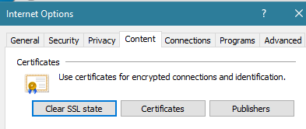

1. Go to **Advance** tab (Make sure these options are selected/deselected as below)

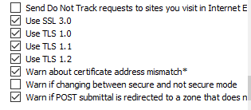

**OTUSM site:** https://ot.ims.att.com/ot/web/OTlogin.html (Load balancer)

**ARESS:** <https://smrpt.mt.att.com/cgj-bin/gx.cgi/applogic+ot.prodtool.DBupdateTool>

Make sure you have access to below profile:

**Backend**

OT_USM_SDP_PROD_order_fall_out (Prod Ops)

**Frontend**

Application support (Prod Ops)

SMI User (Prod Ops)

NCON Manager (Prod Ops)

NCON (PVT , Prod Ops)